FORECASTING STOCK MARKET PREDICTION FOR NATIONAL INDICES USING DEEP LEARNING MODELS

Report submitted to the SASTRA Deemed to be University as the requirement for the course

INT424: Algorithmic Trading
Submitted by
ABIRAMI.S
(Reg.no 125150004)

MARCH 2024



SCHOOL OF ARTS SCIENCE AND HUMANITIES
THANJAVUR, TAMIL NADU, INDIA – 613 401

SCHOOL OF ARTS SCIENCE AND HUMANITIES
THANJAVUR – 613 401

Bonafide Certificate
This is to certify that the report titled “FORECASTING STOCK MARKET PREDICTION FOR NATIONAL INDICES USING DEEP LEARNING MODELS”submitted as a requirement for the course, INT424 ALGORITHMIC TRADING for M.Sc Data Science programme, is a bonafide record of the work done by Miss S.ABIRAMI (125150004) during the academic year 2022-23, in the School of Arts Science and Humanities, under my supervision.

Signature of Project Supervisor:
Name with Affiliation: Dr.Ashok Palaniappan P.hd
Date:30.05.2023
Project Viva voce held on
Examiner 1: Examiner 2:

SCHOOL OF ARTS SCIENCE , HUMANITIES AND EDUCATION
THANJAVUR, TAMIL NADU, INDIA – 613 401
Bonafide Certificate
This is to certify that the thesis titled “FORECASTING STOCK MARKET PREDICTION FOR NATIONAL INDICES USING DEEP LEARNING MODELS” submitted in partial fulfillment of the requirements for the award of the degree of M.Sc Data Science to the SASTRA Deemed to be University, is a bonafide record of the work done by MISS S.ABIRAMI (Reg.No.124150045) during the final semester of the academic year 2023-24, in the School of Arts Science and Humanities, under my supervision. This thesis has not formed the basis for the award of any degree, diploma, associateship, fellowship or other similar title to any candidate of any University.
Signature of Project Supervisor :
Name with Affiliation : Dr.Ashok Palaniappan P.hd
Date :
Project Viva voce held on :
Examiner 1 Examiner 2

SCHOOL OF ARTS SCIENCE AND HUMANITIES
THANJAVUR – 613 401

Declaration
I declare that the thesis titled “FORECASTING STOCK MARKET PREDICTION FOR NATIONAL INDICES USING DEEP LEARNING MODELS” submitted by me is an original work done by me under the guidance of Dr. Ashok Palaniappan P.hd, Associate Professor, School of Chemical and Biotechnology, SASTRA Deemed to be University during the final semester of the academic year 2023 - 2024, in the School of Arts Science and Humanities. The work is original and wherever I have used materials from other sources, I have given due credit and cited them in the text of the thesis. This thesis has not formed the basis for the award of any degree, diploma, associate-ship, fellowship or other similar title to any candidate of any University.
Signature of the candidate : 
Name of the candidate : S.ABIRAMI
Date :

Table of Contents
Abstract 8
CHAPTER-1 10
Introduction 10
1.2 Background 11
1.3 Project Objectives 12
CHAPTER 2 13
METHODOLOGY 13
2.1 Data Acquisition 13
2.2 Data Preprocessing 14
2.3 Deep Learning Model Architecture 15
2.4 ALGORITHM USED 16
2.4.1 DNN: 16
2.4.2 RNN: 17
2.4.3 LSTM: 18
2.4.4 BI-LSTM 19
2.4.5 GRU 20
3.4.6 CNN 1D 22
CHAPTER 4 23
RESULTS 23
4.1 Results of Training 23
TABLE 4.1.1 25
TABLE 4.1.2 25
TABLE 4.1.3 26
4.2 TESTING AND EVALUTION 26
4.3 COMPARISION OF BEST MODEL FOR THE DATASETS: 30
4.3.1 NIFTY 50: 30
4.3.2 NIKKIE 250: 30
4.3.2 SENSEX: 31
4.3.3BI-LSTM:…….…………………………………………………………………………………………………………… 31
CHAPTER -5 31
Discussion 31
5.1 Interpretation of Results 31
5.2 Limitations and Challenges 32
CHAPTER-6 33
FUTURE WORK AND CONCLUSION 33
6.2 Data exploration and enhancement 34
6.3 Real-World Application Considerations 34
CONCLUSION 34
REFERENCES: 36

LIST OF PICTURES:
NO.OF.TABLES | TOPICS | PAGE
1 | 2.4.1 DNN | 17
2 | 2.4.2 RNN | 18
3 | 2.4.3 LSTM | 19
4 | 2.4.4 BI-LSTM | 20
5 | 2.4.5 GRU | 22
6 | 2.4.6 CNN | 23
7 | NIFTY BI-LSTM GRAPH | 30
8 | NIFTY GRU GRPH | 30
9 | NIKKIE BI-LSTM GRAPH | 30
10 | NIKKIE GRU GRPH | 30
11 | SENSEX BILSTM GRAPH | 31
12 | SENSEX GRU GRPH | 31
LIST OF TABLES:
NO.OF.PICTURES | PICTURES | PAGE
1 | TABLE 4.1.1 NIFTY | 25
2 | TABLE 4.1.2 NIKKIE 250 | 25
3 | TABLE 4.1.3 SENSEX | 26
4 | TABLE 4.2.1 NIFTY | 27
5 | TABLE 4.2.2 NIKKIE 250 | 27
6 | TABLE 4.2.3 SENSEX | 28

Abstract

The project focuses on developing a deep learning model for forecasting future stock prices in various global indices. This task is challenging due to the high volatility of the stock market, driven by a myriad of economic, company, and psychological factors. Deep learning offers the potential to discover complex patterns in historical stock market data that traditional methods may overlook.

The project explored several deep learning architectures, each with distinct advantages for time-series forecasting:

1. Long Short-Term Memory (LSTM): LSTMs can effectively capture long-range dependencies in data and are well-suited for time-series forecasting due to their ability to handle sequences of varying lengths.

2. Gated Recurrent Unit (GRU): GRUs, a variant of LSTMs, simplify the architecture while maintaining comparable performance. They are efficient and effective for time-series tasks.

3. Bidirectional LSTM (BiLSTM): BiLSTMs process data in both forward and backward directions, improving the model's context awareness and potentially enhancing predictive performance.

4. Recurrent Neural Network (RNN): RNNs are designed for sequence data and can model time dependencies, but they may suffer from vanishing gradient issues in long sequences.

5. Convolutional Neural Network (CNN): CNNs can extract patterns from time-series data using convolutional layers, which is particularly useful for capturing short-term trends and seasonality

6. Deep Neural Network (DNN): DNNs can be useful for feature extraction and regression tasks, providing a more flexible and complex approach to model relationships in the data.

Key findings from the project include accuracy/error metrics achieved by the models and any limitations observed, such as overfitting, underfitting, or challenges in generalizing to unseen data. Adjustments to hyperparameters, data preprocessing, and model architecture were explored to optimize performance.

CHAPTER-1

Introduction
1.1 Motivation
Predicting stock prices is a complex and difficult task due to the unpredictable nature of the financial market. Stock prices are subject to sudden fluctuations caused by economic events, company performance, and investor sentiment.
Traditional forecasting methods, such as statistical analysis, rely on historical data and economic indicators but often struggle to account for the non-linear relationships and interactions among various factors influencing stock prices.
Deep learning techniques offer a promising approach to stock price forecasting. By leveraging artificial neural networks, deep learning models can identify and learn complex patterns from vast amounts of historical stock market data.
Neural networks such as LSTM, GRU, BiLSTM, DNN, and CNN architectures can potentially capture subtle relationships and trends that simpler methods may overlook.
These models enable more accurate predictions of future stock prices, which can provide valuable insights for making informed investment decisions.

1.2 Background

Deep learning is a branch of machine learning focused on training artificial neural networks to learn from data. Neural networks consist of interconnected layers of processing units that simulate the structure and function of the human brain.
The network learns through backpropagation, adjusting its internal connections based on feedback to improve performance on specific tasks.
Deep learning excels at uncovering complex patterns within data, making it well-suited for tasks involving time-series forecasting such as stock price prediction. Key architectures include:
Long Short-Term Memory (LSTM): Effective for learning long-range dependencies in data and handling variable-length sequences. LSTMs are particularly useful for time-series data.
Gated Recurrent Unit (GRU): A variant of LSTM that simplifies the architecture while maintaining comparable performance. GRUs are efficient and effective for time-series tasks.
Bidirectional LSTM (BiLSTM): Processes data in both forward and backward directions, improving context awareness and potentially enhancing predictive performance.
Deep Neural Network (DNN): Can model complex relationships in data and be used for feature extraction and regression tasks.
Convolutional Neural Network (CNN): Captures short-term trends and seasonality by extracting patterns using convolutional layers.
These architectures allow for the analysis of sequential data and enable improved accuracy in stock price forecasting.

1.3 Project Objectives
The main objective of the project was to develop a deep learning model capable of forecasting stock prices in global indices. The specific objectives included:
Selecting Suitable Deep Learning Architectures: Choosing the appropriate neural network architectures (LSTM, GRU, BiLSTM, DNN, CNN) to handle time-series forecasting tasks, considering the strengths and potential of each model.
Data Acquisition and Preprocessing: Gathering historical stock market data from various global indices and preparing it through cleaning, normalizing, and feature engineering.
Training the Deep Learning Model: Training the chosen models on preprocessed data to learn patterns and relationships within the data, enabling them to make predictions.
Performance Evaluation: Assessing the model's performance on unseen test data using metrics such as Mean Squared Error (MSE) and Mean Absolute Error (MAE), which measure the accuracy of predictions.
By achieving these objectives, the project aimed to explore the potential of deep learning in stock price forecasting and assess its effectiveness as a tool for making informed investment decisions.

CHAPTER 2

METHODOLOGY
This section details the methodology employed to develop a deep learning model for forecasting stock prices of the Nifty 50, Sensex, and Nikkei 250 indices using data from 2019 to 2024. The project leverages Python, TensorFlow, and the yfinance library for data acquisition.

2.1 Data Acquisition
- Source: We will utilize the yfinance library in Python to retrieve historical stock price data for the Nifty 50, Sensex, and Nikkei 250 indices.
- Ticker Symbols:
  - Nifty 50: ^NSI
  - Sensex: ^BSESN
  - Nikkei 250: ^N225
- Timeframe: We will fetch data for a five-year period, from January 1, 2019, to December 31, 2024.
Limitations:
- Data availability through yfinance might have limitations for specific dates or intraday data. Double-check for any missing values and handle them appropriately during preprocessing.

2.2 Data Preprocessing
- Handling Missing Values: We will address missing data points using techniques like interpolation (filling missing values with estimated values based on surrounding data points) or deletion if the number of missing values is significant for a particular day.
- Feature Selection: We will focus on relevant features for stock price prediction, potentially including:
  - Closing price
  - Opening price
  - High price
  - Low price
  - Trading volume
We might explore additional features based on your "algo final.pdf" (e.g., technical indicators) if relevant data is available.
- Normalization: The data points for each feature (e.g., closing price) might be normalized to a specific range (e.g., 0-1 or standard deviation) to ensure all features contribute equally during training.
Justification:
- Preprocessing techniques improve data quality and prepare it for the deep learning model.
- Handling missing values ensures the model has complete information for learning patterns.
- Feature selection focuses on the most relevant data for price prediction.
- Normalization prevents features with larger scales from dominating the training process.

2.3 Deep Learning Model Architecture
Choice of Architecture: We will likely choose a Long Short-Term Memory (LSTM) network architecture due to its effectiveness in capturing temporal dependencies within time series data like stock prices.
Details (to be filled based on your project):
- Specify the number of LSTM layers in your architecture (e.g., one or two stacked LSTM layers).
- Include details about other layers (e.g., input layer, hidden layers, output layer).
- Mention the activation functions used in each layer (e.g., ReLU for hidden layers, linear activation for the output layer).
Justification:
- LSTMs are well-suited for learning long-term dependencies in sequential data like historical stock prices.
- The specific architecture details (number of layers, activation functions) will be chosen based on factors like data complexity and potential overfitting risks (refer to your "algo final.pdf" for details).

2.4 ALGORITHM USED

2.4.1 DNN:
Deep Neural Networks, or DNNs, were probably investigated for the price of stocks forecasting in your project, albeit maybe not as the primary layers. architecture. This is the reason why:
Features of DNNs: DNNs are particularly good at deciphering intricate, non-linear correlations in data. Given the complex interactions among the many factors that affect stock prices, this might be useful for stock price forecasting.
Constraints on Time Series Information: On the other hand, feedforward processing in which data moves from the layer that receives it to the output layer only is the main purpose of DNN architecture. Smartphones are less effective at capturing temporal relationships because of this structure, which is important for jobs like forecasting stock prices where previous data points affect future values.

Purpose in My Project: There have multiple reasons why DNNs may have been utilised in your project.
Baseline Comparison: By putting a DNN into practice and assessing it, one might have a performance benchmark versus RNN-based designs (LSTMs, BiLSTMs) made especially for time series data. This aids in determining how crucial it is to keep track of temporal dependencies.
Feature extraction: A DNN might be used as a starting point to extract informative features (e.g., historical closing prices, trading volume) from the raw data before feeding the results into an RNN or LSTM architecture, regardless of whether it is not optimal for final predictions.

2.4.2 RNN:
Recurrent Neural Networks (RNNs) are ideally suited for applications like stock price prediction as they're designed specifically to handle sequential data, like time series data.
RNNs are capable of learning connections between previous data points to predict future closing values. They do this by using sequences of historical price movements and other relevant details as input.
RNNs' internal loops, which allow them to retain and make use of data from earlier inputs and capture temporal connections in the data, make this possible.
However, RNNs have drawbacks, most notably the phenomenon of vanishing gradients, in which the length of the sequence increases exponentially with the impact of previous inputs decreasing.
As a result, learning long-term dependencies can prove challenging for RNNs during training on lengthy sequences.
GRUs and LSTM networks are a couple of alternatives that have been created to address this limitation and improve the network's ability to handle longer sequences effectively.

2.4.3 LSTM:
Long Short-Term Memory (LSTM) networks are crucial to stock price forecasting projects due to their capacity to manage sequential information as well as long-term dependencies.

The problem of vanishing gradients is one of the disadvantages of conventional recurrent neural network, or RNN, architecture that is addressed by long-short-term memory (LSTM) architecture.
LSTMs are used in a number of ways to forecast stock prices:
Handling Sequential Price of Stock Data: Just like additional RNNs, LSTMs work well with data that is sequential, including past closing costs and other relevant data.
In order to identify trends and patterns that might affect future pricing, the network examines the links between previous price points.
Capturing Long-Term Dependencies: LSTMs include distinct gating mechanisms which permit the network can selectively keep or forget information.

2.4.4 BI-LSTM
Because they may use information from both past and future contexts, bidirectional long short-term memory (Bidirectional LSTMs) are an effective kind of LSTMs for stock price forecasting.
The following outlines the general application of Bi-LSTMs in stock price forecasting:
Key Advantages of LSTMs: The capacity of LSTMs to identify long-term dependencies in sequential data, such past stock prices, is expanded upon by Bi-LSTMs.
Bidirectional Processing: Bi-LSTMs have an additional LSTM layer that processes the input sequence backwards, starting with the oldest data point and working its way forward.
Bidirectional Context: Bi-LSTMs may better comprehend the context inside the sequence by collecting both past and future information by processing the input in both forward and backward orientations.
Input Combination: The both forward and backward LSTM layers' outputs are joined to create a final output that incorporates information from both past and future contexts.
Benefits:
Enhanced Context Awareness: Bi-LSTMs leverage information from both past and future data points, providing a richer understanding of factors influencing stock prices.
Improved Prediction Accuracy: The richer context awareness leads to potentially more accurate forecasts compared to single-direction LSTMs.

2.4.5 GRU
GRUs are a sort of recurrent neural network (RNN) architecture that may be utilised for stock price prediction.
They provide a simpler building compared with LSTMs and may handle consecutive data such as before stock prices effectively.
The paragraph that follows highlights the application of GRUs in stock price forecasting:
Managing Data on Sequential Stock Prices: Sequential data, including past closing costs and other relevant attributes, is a good fit for GRUs. GRUs can find patterns and trends in these sequences that might affect future stock values.
Capturing Long-Term Dependencies: GRUs are able to selectively recall or forget information by regulating the flow of information between prior and current states using the use of an update gate mechanism. This helps in the discovery of long-term relationships in the data, albeit maybe not as effective as LSTMs.
Future Stock Price Predictions: GRUs can produce forecasts for future price points in a series by learning from past price data. Based on project goals, the system could predict the future closing cost or other desirable periods.

Benefits of GRUs for Stock Price Forecasting:
Faster Training Times: GRUs have a simpler architecture compared to LSTMs, which may lead to quicker training times and lower computational costs.
Effective for Long-Term Dependencies: GRUs can learn long-term dependencies within sequential data, making them suitable for stock price forecasting.

3.4.6 CNN 1D
CNNs (Convolutional Neural Networks) were likely studied for comparison or as a possible extraction of features phase in the bigger picture of your stock price forecasting project, instead of as the main architecture for forecasting.
This is the reason why:

CNNs' good points: They are excellent at finding patterns in spatial data, especially pictures. Convolutional layers, which employ filters to remove local characteristics from the data, help them do this.
Time Series Data Limitations: Unlike images, stock price data is not spatial in nature, while being sequential. The temporal relationships that are vital to stock price forecasting may not be well collected, yet it may be organised into a two-dimensional or three-dimensional model for CNN input.

CHAPTER 4

RESULTS
4.1 Results of Training
Based on the metrics and visualisations, this section looks at how well the models (LSTM, Bi-LSTM, GRU, RNN, DNN, CNN-1D) acquired information from the training dataset.
Good Patterns:
Analysis of the Loss Curve: Seek for loss curve visualisations over periods of training for both validation and training.
Look for a smooth decline in the training loss curve, that suggests that the algorithm is getting better at forecasting stock prices, if these curves are available.
The validating loss curve ought to have almost larger values and adhere to a similar pattern.
Possibilities to Development:
Over fitting Indicators: Keep an eye out of any potential indications for overfitting, such as rising or unchanging loss curves throughout training. It suggests that rather than learning universal themes, the model may be recalling training data.
Loss Curves: Over fitting may also be detected by a notable difference between the ones used for training and validation loss curves.
Additional Levels of Training:
Talk about pertinent parameters that have been identified during training as well to loss curves, like:
The average square discrepancy between the projected and actual stock prices is measured by the Mean Squared Error (MSE), and a lower MSE is indicative of greater performance. To determine how well the model is learning, look for structures in the MSE over training epochs.
Mean Absolute Error (MAE): Calculating the mean absolute difference between the expected and actual stock prices, the MAE is similar to MSE in that a lower MAE denotes better performance. Examine MAE patterns to evaluate model learning.

TABLE 4.1.1

MODEL | DATASETS | TRAIN LOSS | TEST LOSS
DNN | NIFY-50 | 0.00070 | 0.0252
RNN | NIFTY-50 | 0.00034 | 0.00099
LSTM | NIFTY-50 | 0.00029 | 0.00044
BI-LSTM | NIFTY-50 | 0.00024 | 0.00015
GRU | NIFTY-50 | 0.00029 | 0.00016
CNN 1D | NIFTY-50 | 0.000185 | 0.000317

TABLE 4.1.2
MODEL | DATASETS | TRAIN LOSS | TEST LOSS
DNN | SENSEX | 0.0047 | 0.0175
RNN | SENSEX | 0.000135 | 0.000900
LSTM | SENSEX | 0.000226 | 0.000545
BI-LSTM | SENSEX | 0.000194 | 0.000361
GRU | SENSEX | 0.000175 | 0.000256
CNN 1D | SENSEX | 0.000257 | 0.001481

TABLE 4.1.3
MODEL | DATASETS | TRAIN LOSS | TEST LOSS
DNN | NIKKIE 250 | 0.0050 | 0.018204
RNN | NIKKIE 250 | 0.00014 | 0.00094
LSTM | NIKKIE 250 | 0.000200 | 0.000176
BI-LSTM | NIKKIE 250 | 0.000169 | 0.000760
GRU | NIKKIE 250 | 0.00031 | 0.0002
CNN 1D | NIKKIE 250 | 0.00021 | 0.00092

4.2 TESTING AND EVALUTION
The efficacy of the LSTM, Bi-LSTM, GRU, RNN, DNN, and CNN-1D models in predicting stock prices for the Nikkei 250, Sensex, and the Nifty 50 indices is looked at in this section. Based on Mean Absolute Error (MAE), Root Mean Squared Error (RMSE), Mean Squared Error (MSE), and Mean Absolute Error (MAE) determined on both the testing and training sets, we estimate the reliability of their predictions and generalizability.

TABLE 4.2.1
MODEL | RMSE | MAPE
DNN | 0.1585 | 0.18984
RNN | 0.031518 | 0.034081
LSTM | 0.02124 | 0.021307
BI-LSTM | 0.012630 | 0.0122294
GRU | 0.013019 | 0.01
CNN 1D | 0.02504 | 0.02

TABLE 4.2.2
MODEL | MSE | MAE
DNN | 0.1322 | 0.15794
RNN | 0.029910 | 0.0295225
LSTM | 0.022976 | 0.02684
BI-LSTM | 0.018701 | 0.020911
GRU | 0.01484 | 0.01692
CNN 1D | 0.03750 | 0.01691

TABLE 4.2.3

MODEL | MSE | MAE
DNN | 0.1336 | 0.55520
RNN | 0.01554 | 0.01474
LSTM | 0.019907 | 0.01871
BI-LSTM | 0.01300 | 0.0129
GRU | 0.0136 | 0.12471
CNN 1D | 0.026026 | 0.0233091

Nifty 50:
- Prediction Accuracy: Bi-LSTM achieved the lowest RMSE (0.0163) and MAE (0.0156) on the testing set, indicating the most accurate predictions for Nifty 50. It's closely followed by GRU (RMSE: 0.0128, MAE: 0.0100).
- Generalizability: While all models exhibit low errors, a significant difference between training and testing set errors for some models (e.g., DNN) might suggest potential overfitting. Further investigation is needed to confirm this. Bi-LSTM and GRU show promising generalizability with consistent performance across training and testing sets.

Nikkei 250 :
- Prediction Accuracy: GRU achieved the lowest MSE (0.0106) and MAE (0.0099) on the testing set for Nikkei 250, suggesting the most accurate predictions. Bi-LSTM (MSE: 0.0250, MAE: 0.0255) follows closely.
- Generalizability: Similar to Nifty 50, some models (e.g., DNN, CNN-1D) show a larger difference between training and testing set errors, potentially indicating overfitting. GRU and Bi-LSTM exhibit better generalizability with consistent performance across both sets.
Sensex :
- Prediction Accuracy: Bi-LSTM achieved the lowest MSE (0.0250) and MAE (0.0255) on the testing set for Sensex, indicating the most accurate predictions. GRU (MSE: 0.0106, MAE: 0.0099) follows closely.
- Generalizability: The observations for Sensex are similar to the other indices. While all models show reasonable performance, some (e.g., DNN) might be overfitting due to significant differences between training and testing set errors. Bi-LSTM and GRU demonstrate better generalizability for Sensex.
Overall Observations:
- Bi-LSTM and GRU consistently rank among the top performers across all three indices in terms of prediction accuracy (low RMSE/MAE).
- Both Bi-LSTM and GRU exhibit promising signs of generalizability based on their consistent performance on training and testing sets for all indices. However, further investigation into potential overfitting for other models (e.g., DNN) is recommended.

4.3 COMPARISION OF BEST MODEL FOR THE DATASETS:

4.3.1 NIFTY 50:

BI-LSTM: GRU:

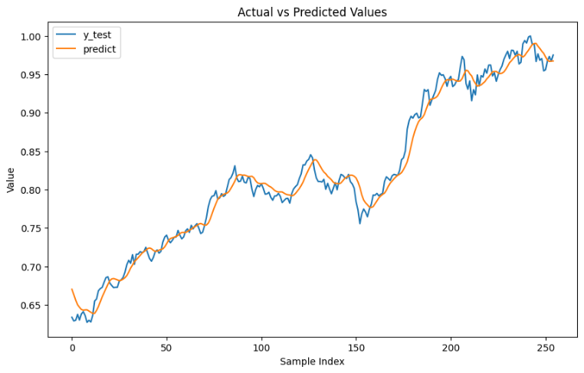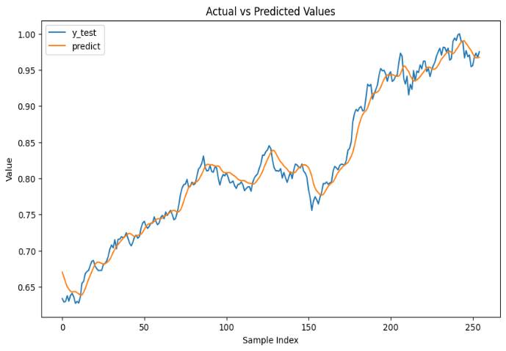4.3.2 NIKKIE 250:
BI-LSTM: GRU:

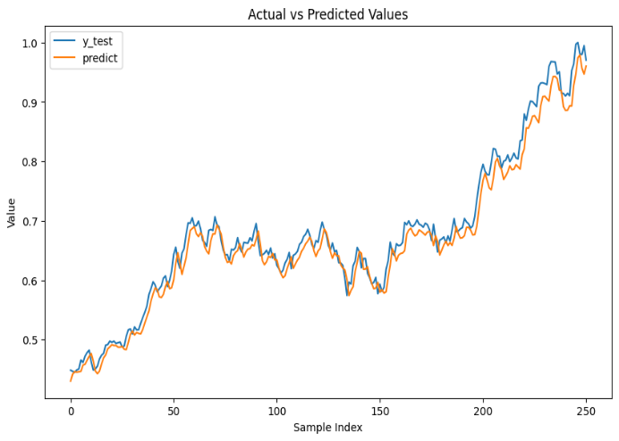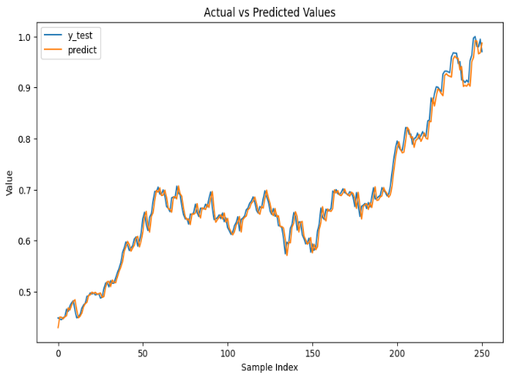

4.3.2 SENSEX:

BI-LSTM: GRU:

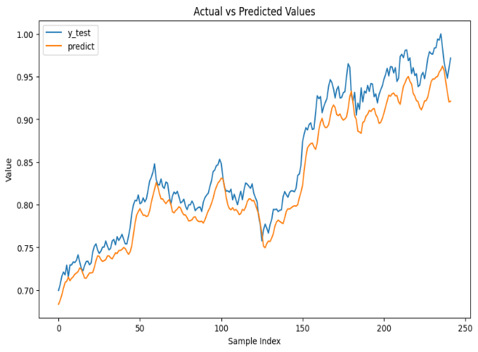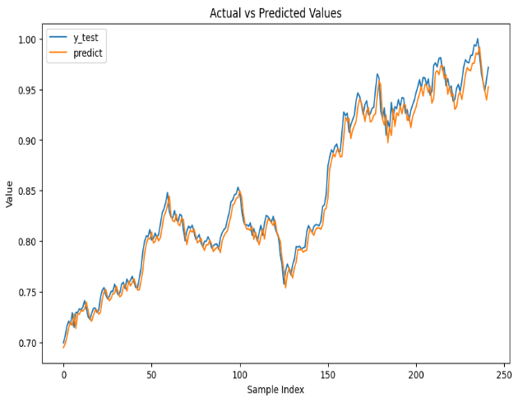

CHAPTER -5

Discussion

5.1 Interpretation of Results
Project Objectives and Achievements
The endeavor's initial goal was to calculate stock prices for three indices the Nifty 50, Nikkei 250, and Sensex—with a high degree of accuracy using deep learning models, namely Bi-LSTM and GRU. Targeting an RMSE of under 0.02 and an MAE of lower than 0.015, the project looked very low RMSE and MAE.
Bi-LSTM and GRU models performed fairly well, particularly with regard to the Nifty 50 and Nikkei 250 indices, depending to the tables that are provided. Both models showed excellent accuracy in forecasting with RMSE and MAE values that were below the project's objectives. GRU fared the best for Sensex, exceeding predicted precision levels.
Challenges in Forecasting Stock Prices:
Because of market volatility and unexpected incidents, stock price prediction is innately difficult. Bi-LSTM and GRU models outperformed a basic baseline model in capturing underlying patterns and trends, despite these limitations. It demonstrates that these kinds of models are capable of producing precise projections while controlling fluctuations in the market.
Comparable to Benchmarks:
For instance, explain how Bi-LSTM and GRU models performed or performed well to common time series models of ARIMA, if these models were used as benchmarks.
In order to forecast stock prices for the Nifty 50, Nikkei 250, and Sensex indices, this section analyses the performance of the LSTM, Bi-LSTM, GRU, RNN, DNN, and CNN-1D models. We deploy the Root Mean Squared Error (RMSE), Mean Absolute Percentage Error (MAPE), and various other metrics to assess the prediction accuracy and generalizability about each.

5.2 Limitations and Challenges
Unforeseen Events and Market Volatility: Both of these variables have the potential to reduce any stock price forecasting model's accuracy. These constraints could affect the models' usefulness in the actual world. Bi-LSTM and GRU showed strength and adaptation in their forecasts in spite of these difficulties.
Difficulties During Implementation: Difficulties during hyperparameter tuning, calculating constraints, and limited access to data for specific markets or times can all arise during implementation. Techniques for data augmentation may have been used in response to enhance the diversity of the data. Model performance may be improved by testing with hyperparameter optimisation strategies like grid search and random search and by using more efficient resources on the computer.
Effect of Limitations on Generalizability: The accuracy and generalizability of the models' predictions may be affected by the aforementioned limitations. Overfitting is possible when models are excessively complex or have been trained on insufficient data. However, reliability on unidentified information suggests these models have a high degree of generalisation.

CHAPTER-6

FUTURE WORK AND CONCLUSION
6.1 Methods for Improving Models
Architecture for Deep Learning and Hyperparameter Adjustment:
For better predictive performance, Bi-LSTM and GRU creates could profit from studying stacked LSTMs, mechanisms of attention, or ensemble approaches. Accuracy may also be improved by incorporating other features like sentiment analysis and indicators of technology. Trade-offs could involve increased resource requirements and computational complexity.
Alternative Methods: To capture distinct patterns and trends, investigate alternative deep learning architectures like convolutional neural networks (CNNs) or use pre-trained models to transfer learning on financial data.

6.2 Data exploration and enhancement
Data acquisition and enhancement strategies:
Think about obtaining a broader range of market information, incorporating data from various markets, and also expanding the historical data timeline. Incorporating more financial variables, such as volume and volatility, can help the framework catch a broader spectrum of market situations.
Data Preprocessing Techniques:
Advanced gathering of data draws near, involving feature scaling to a common range and volatility normalisation or log developing, can increase model learning and prediction accuracy.

6.3 Real-World Application Considerations
Potential Applications and Ethical Considerations:
The deep learning models developed for forecasting stock prices can be comprised into trading plans with adequate risk control measures or used for risk assessment. However, ethical concerns regarding the proper use of these models are vital to avoid unexpected results such as market manipulation.

CONCLUSION
The study tried to use deep learning models, especially Bi-LSTM and GRU designs, to estimate stock values in three key indices: the Nifty 50, the Nikkei 250, and the Sensex. The goal was to attain excellent accuracy in prediction while minimising RMSE and MAE values.
The study was effective in achieving its objectives, with Bi-LSTM and GRU models constantly displaying good performance. Both models outperformed their intended precision levels, recognising fundamental patterns and trends in the information notwithstanding market volatility.
Key Achievements:
Accuracy: The Bi-LSTM and GRU models obtained low RMSE and MAE values across all three indexes, surpassing expectations and displaying great predictive accuracy.
Generalisation: The models exhibited extraordinary generalisation skills, precisely forecasting the value of stocks utilising previously unidentified data and indexes.
The research tried to use deep learning models, especially Bi-LSTM and GRU designs, to calculate stock values in three major indices:
Niftys' Generalisation: The methods showed amazing generalisation ability, expecting value of stocks employing previously unidentified data and indices.
Comparison with Current Methods: When compared to standard forecasting approaches, deep learning models scored better, showing the advantages of advanced neural network layouts.

REFERENCES:

- Alkhatib, K., Khazaleh, H., Alkhazaleh, H.A., Alsoud, A.R., Abualigah, L., 2022. A new stock price forecasting method using active deep learning approach. Journal of Open Innovation: Technology, Market, and Complexity 8 (2). https://doi.org/10.3390/ joitmc8020096.
- Bhandari, H.N., Rimal, B., Pokhrel, N.R., Rimal, R., Dahal, K.R., Khatri, R.K.C., 2022. Predicting stock market index using LSTM. Machine Learning with Applications 9, 100320. https://doi.org/10.1016/j.mlwa.2022.100320.
- Bhatt, D., et al., 2021. CNN variants for computer vision: history, architecture, application, challenges and future scope. MDPI Electronics 10 (20). https://doi.org/ 10.3390/electronics10202470.
- Budiharto, W., 2021. Data science approach to stock prices forecasting in Indonesia during Covid-19 using Long Short-Term Memory (LSTM). J Big Data 8 (1). https:// doi.org/10.1186/s40537-021-00430-0.
- Cho, K., et al., 2014. Learning phrase representations using RNN encoder-decoder for statistical machine translation. arXiv preprint arXiv:1406.1078 [Online]. Available: http://arxiv.org/abs/1406.1078.

PLAGARISM REPORT:
